**EXAMPLE # 1: ICP Organizational Structure**[1]

Senior Vice President Strategy and Product Management

Director

Common Unit Trade

Compliance

Manager

General Trade Compliance

Manager

Process and Project Office

Manager

U.S. Re-Export

Compliance

Employees

Employees

Employees

Vice President Government Affairs and Regulation

CEO

**EXAMPLE # 2: ICP Organizational Structure[2]**

Chief Executive Officer (CEO) / Enterprise’s Senior Management

Technical Committee Designated Department Trade Compliance Managers/Officers (TCM/TCO)

Chief Compliance Officer (CCO)/ Compliance Unit

Compliance Manager/Officer

Subsidiary/Affiliated Departments

Department Trade Compliance Managers/Officers (TCM)/(TCO)

**EXAMPLE # 3: ICP Organizational Structure**

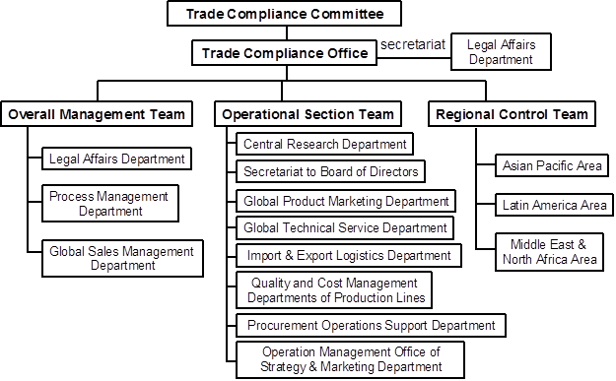

**EXAMPLE # 4: ICP Organizational Structure (CHIYODA Corporation – Japan)[3]**

At Chiyoda Corporation of Japan, strategic trade controls are administered with the organizational structure constituted by the Export Control Committee, where the Compliance Unit serves as the Committee’s Secretariat, under the immediate direction of the Executive Committee. The routine STC compliance activities are carried out by export control coordinators assigned in each organizational unit, and are followed up on as a double-check by the Compliance Unit for reconfirmation.

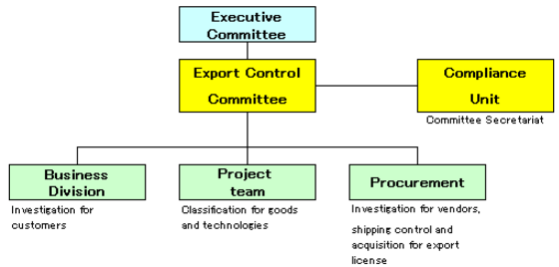

**EXAMPLE # 5: ICP Organizational Framework (TOSHIBA Group)**

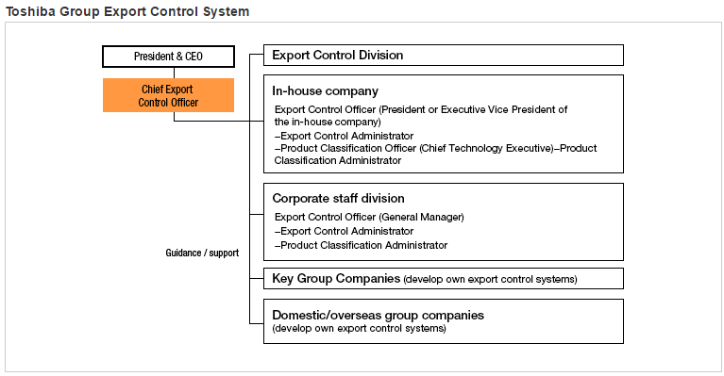[Note: *This example accounts for domestic and overseas subsidiaries and affiliates.*]

1. Source: Ulf Pehrsson, VP Government Affairs and Regulations, Ericsson, “Dual Use Export Compliance within Ericsson,” presented at the Seventh Annual International Export Control conference, Stockholm, Sweden, September 2005, <http://www.exportcontrol.org/library/conferences/1379/005_Industry_Internal_Compliance_-_Ulf_Pehrsson.pdf>.
2. Source: “Internal Compliance Programme Guidelines,” Pakistan Ministry of Foreign Affairs, Strategic Export Control Division (SECDIV), 3 October 2014, <http://www.mofa.gov.pk/secdiv/documents/ICP-Guidelines.pdf>.
3. Source: “Export Control," Chiyoda Corporation, Japan, 2017, <https://www.chiyoda-corp.com/csr/en/compliance/security.html>.